1. How many observations are there in the dataset?

500

1. How many variables are there in the dataset?

4

1. What is the average value for the Hrs variable? Round it off to 2 decimal places.

11.31

1. Are there outliers in the Hrs variable?

Yes

1. What is the mode of the employee performance in the rating column?

Excellent

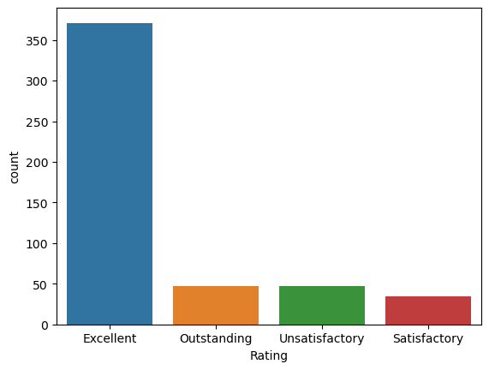

1. Calculate the range of hours the employee is working for in case of unsatisfactory rating.

Min: 0.091720, Max: 8.489765

1. Check out the distribution of the Hrs variable using histogram and boxplot. Where do we have the outliers?

Both side

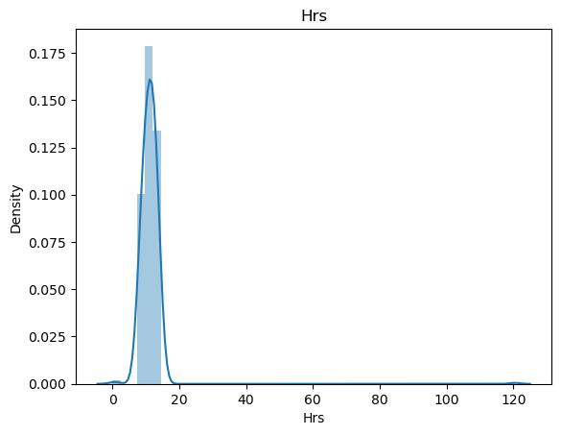

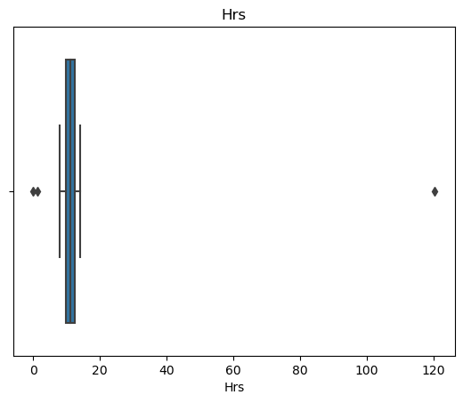

1. Which rating has the highest number of average working hours?

Outstanding

1. Identify the correct upper and lower cut off within Hrs using IQR rule to exclude the outliers. Round off to 2 decimal places.

Upper bound: 16.98

Lower bound: 5.35

1. After treatment with the outliers, what’s the mean value for Hrs variable?

11.13

1. After treatment of outliers, which rating isn’t witnessing changes with respect to Hrs variable?

Outstanding

1. Identify the probabilities for each rating within the dataset.

Excellent: 74.2%, Outstanding: 9.4%, Satisfactory: 7%, Unsatisfactory: 9.4%

1. Calculate the probability that 2 out of a sample of 10 employees are rated as outstanding.

0.18

1. Calculate the probability that at least 3 out of a sample of 10 employees are rated as outstanding.

0.06

1. Calculate the probability that at least 7 out of a sample of 10 employees are rated as outstanding or Excellent. Round it off to 2 decimal point.

0.15

1. Calculate the probability that None of the trainees are rated as Unsatisfactory.

0.37

1. Assuming that this variable follows close to normal distribution, what’s the probability that an employee will provide less than 9 hrs of service?

0.11

1. What’s the probability that an employee will provide hours of service between 11 to 14?

0.48

1. Calculate the 95% Confidence interval for the average of Hrs variable.

10.97, 11.28